TITLE OF THESIS

STUDENT NAME SURNAME

MONTH AND YEAR OF THESIS DEFENSE

ÇANKAYA UNIVERSITY

GRADUATE SCHOOL OF NATURAL AND APPLIED SCIENCES

CHOOSE DEPARTMENT
Choose Thesis Type.
Choose Program

TITLE OF THESIS

STUDENT NAME AND SURNAME

MONTH AND YEAR OF THESIS DEFENSE

Title of Thesis:

Submitted by:

Approval by the Graduate School of Natural and Applied Sciences, Çankaya University
_____________________
Prof. Dr. XXXX XXXXX
Director

I certify that this thesis satisfies all the requirements as thesis for the degree of Bir öğe seçin.
_____________________
Prof. Dr. XXXX XXXXX
Head of Department
This is to certify that I have read this thesis and that in my opinion it is fully adequate in scope and quality, as thesis for the degree of Choose Program
_____________________
Prof. Dr. XXXX XXXXX
Co-Supervisor
_____________________
Prof. Dr. XXXX XXXXX
Supervisor

Thesis Defense Date:

Thesis Jury Members:
Prof. Dr. XXX XXX | Çankaya University | _____________________
Assoc. Dr. XXX XXX | …………………………... | _____________________
……………………….. | ………………………...… | _____________________
……………………….. | ……………………….….. | _____________________
……………………….. | …………………………… | _____________________

STAMENT OF NONPLAGIARISM

I hereby declare that all statements in this statement has been obtained and presented in accordance with academic rules and ethical conduct. I also declare that, as required by these rules and conduct, I have fully cited and referenced all material and results that are not original to this work.

Name Last Name:
Signature:
Date:

ABSTRACT

TITLE OF THESIS

LAST NAME, NAME
Choose Program

Supervisor: Assoc. Prof. Dr. XXXXXXXXXX
Co-Supervisor: Assist. Prof. Dr. XXXXXXXXX
Defense Date MONTH YEAR, PAGE NUMBER (October 2022, 18)

Indented paragraph must be when starts to write thesis. First line option selects from paragraph settings and by section adjust 1.25 cm or press CTRL + TAB or TAB when you write abstract. Abstract should be written 12 Punto and Times New Roman, alignment should be justified and line spacing should be 1.5 lines
Line spacing should be 1.5 lines among paragraphs
…………….………………………………………………………………………………………………………………………………………………………………………………………………………………………………………………………………………………………………………………………………………………………………………………………………………………………………………………………………………………………………………………………………………………………………………………………………………………………………………………………………………………………………………………………………………………………………………………………………………………………

Keywords: It should be written at least 3 word maximum 6 words. Only first letter of keyword should be capital. Comma should be placed among keywords. Keyword should be started by giving 1 line space after the end of the abstract.

ÖZET

TEZ BAŞLIĞI

SOYAD, AD
Choose Program

Danışman: Prof. Dr. Xxxx
Ortak Danışman: Doç. Dr. Xxxx
Savunma Tarihi Ay Yıl, Sayfa Sayısı (Ekim 2022, 18)

...........................................................................................................................................................................................................................................................................................................................................................................................................................
……………………………………………………………………………………………………………………………………………………………………………………………………………………………………………………………………….………………………………………………………………………………………….………………………………………………………………………………………….………………………………………………………………………………………….………………………………………………………………………………………….………………………………………………………………………………………….………………………………………………………………………………………….………………………………………………………………………………………….

Anahtar Kelimeler:

ACKNOWLEDGEMENT

………………………………………………………………………………………………………………………………………………………………………………………………………………………………………………………………………………………………………………………………………………………………….………………………………………………………………………………………….………………………………………………………………………………………….………………………………………………………………………………………….………………………………………………………………………………………….………………………………………………………………………………………….………………………………………………………………………………………….………………………………………………………………………………………….………………………………………………………………………………………….………………………………………………………………………………………….………………………………………………………………………………………….

TABLE OF CONTENTS

STAMENT OF NONPLAGIARISM iii

ABSTRACT iv

ÖZET v

ACKNOWLEDGEMENT vi

LIST OF TABLE viii

LIST OF FIGURES ix

LIST OF SYMBOLS AND ABBREVIATIONS x

CHAPTER I 1

FIRST LEVEL TITLE 1

1.1 SECOND LEVEL TITLE 1

1.1.1 Third Level Title 1

1.1.1.1 Fourth Level Title 1
1.1.1.1.1 Fifth Level Title 1
1.1.1.1.1.1 Sixth Level Title 1

1.1.1.1.1.1.1 Seventh Level Title 1

CHAPTER II 2

HOW TO MAKE LIST OF TABLES AND FIGURES AND WHAT ARE THESE FORMATS ? 2

2.1 TO arrange TABLE and make a table of lıst 2

2.2 HOW TO INSERT FIGURES AND HOW TO LISTED 3

CHAPTER III 4

ABOUT THE REFERENCES 4

3.1 RULES OF REFERENCES 4

REFERENCES 5

APPENDICES 6

LIST OF TABLE

Table 1: Information about Thesis 2
Table 2: Number of students in M.Sc. and Ph.D. 2

LIST OF FIGURES

Figure 1: Satellite view of Çankaya University 3
Figure 2: Second Satellite view of Çankaya University 3

LIST OF SYMBOLS AND ABBREVIATIONS

SYMBOLS

ABBREVIATIONS
cm | :Centimetre

CHAPTER I

FIRST LEVEL TITLE

Style - Heading 1 must be selected which is founded in section Home- Style in word to First Level Title. All level titles are arranged in Styles section. You can reach more information from Thesis Manuel.

SECOND LEVEL TITLE
Style – Heading 2 must be selected which is founded in section Home- Style in word to Second Level Title.

Third Level Title
Style – Heading 3 must be selected which is founded in section Home- Style in word to Third Level Title.

Fourth Level Title

Fifth Level Title

Sixth Level Title

Seventh Level Title

CHAPTER II

HOW TO MAKE LIST OF TABLES AND FIGURES AND WHAT ARE THESE FORMATS ?

TO arrange TABLE and make a table of lıst
For a basic table, click Insert > Table and move the cursor over the grid until you highlight the number of columns and rows you want. For a larger table, or to customize a table, select Insert > Table > Insert Table. After your table is arranged, to write your tables explanations top your tables. you can follow these steps; Home > Styles > Table Writing, Figure Writing. You can create and update your table list with these steps; References > Instert Tables of Figures > General > Caption Label > Table. One line space must be before table explanation and end of the table.

Table 1: Information about Thesis
Heading of Tables | Page Number | Number of Article

Table 2: Number of students in M.Sc. and Ph.D.
Bölüm | Öğrenci Sayısı | Tez Sayısı
 | M.Sc.
Computer Engineering | 15 | 5
 | Ph.D.
Design | 3 | 1
Toplam | 18 | 6
It is designed for exemplary purposes

HOW TO INSERT FIGURES AND HOW TO LISTED
For adding any figure to your thesis. Insert > Picture. You must be organized figure with these steps; Picture Layout > In Line with Text and its’ alligment must be centered. After your picture is arranged, to write your tables explanations bottom side of your figures. you can follow these steps; Home > Styles > Table Writing, Figure Writing. You can create and update your figure list with these steps; References > Instert Tables of Figures > General > Caption Label > Figure. One line space must be before figure and after explanation of the figüre.

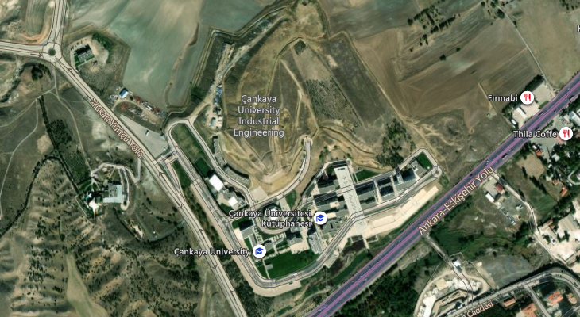
Figure 1: Satellite view of Çankaya University

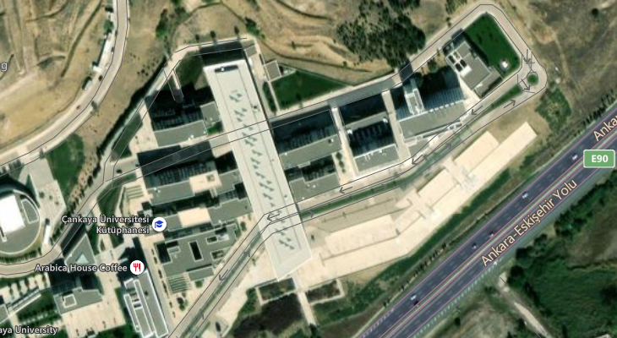
Figure 2: Second Satellite view of Çankaya University

CHAPTER III

ABOUT THE REFERENCES

RULES OF REFERENCES
Our University has its own rules regarding the presenting citiations which are used in your thesis in bibliography section. It is obligatory to use the Thesis Manuel, how to specify sources such as articles, books, journals.

REFERENCES

IT’S ARRANGED ACCORDING TO NUMERICAL METHOD.

[1] JARAD Fahd ve ABDELJAWAD Thabet (2020), “Variational Principles İn The Frame Of Certain Generalized Fractional Derivatives”, Ame. Ins. of Math. Sci., Vol. 13, No. 3, pp. 695-708.
[2] ÇETİNKAYA Ferda Can (1994), “Lot Streaming in a Two-stage Flow Shop with Set-up, Processing and Removal Times Separated”, Journal of the Operational Research Society, Vol 45, pp.. 1445–1455.
[3] DEMİRCAN Tolga, TÜRKOĞLU Haşmet (2005), “Çarpan Osilasyonlu Laminar Jetlerin Akış ve Isı Transferi Karakteristiklerinin Sayısal Analizi”, 15. Ulusal Isı Bilimi ve Tekniği Kongresi, pp.. 543-549, Trabzon.

IT’S ARRANGED ACCORDING TO AUTHOR-DATE METHOD.

ÇETİNKAYA Ferda Can (1994), “Lot Streaming in a Two-stage Flow Shop with Set-up, Processing and Removal Times Separated”, Journal of the Operational Research Society, Vol. 45, pp. 1445–1455.
DEMİRCAN Tolga, TÜRKOĞLU Haşmet (2005), “Çarpan Osilasyonlu Laminar Jetlerin Akış ve Isı Transferi Karakteristiklerinin Sayısal Analizi”, 15. Ulusal Isı Bilimi ve Tekniği Kongresi, pp. 543-549, Trabzon.
JARAD Fahd ve ABDELJAWAD Thabet (2020), “Variational Principles İn The Frame Of Certain Generalized Fractional Derivatives”, Ame. Ins. of Math. Sci., Vol. 13, No 3, pp. 695-708.

APPENDICES

